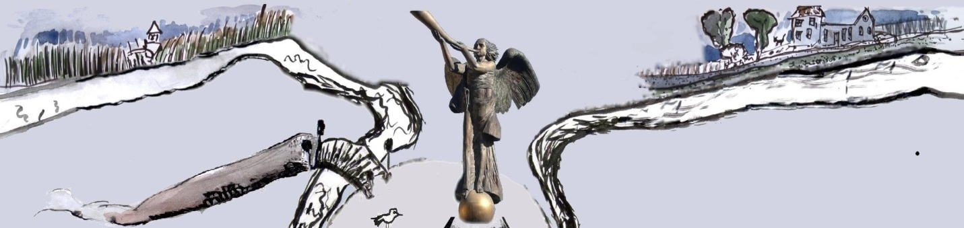
Republique d‘Ouzhoupis * Republic of Uzhupis * Užupio respublika

Ministyrre af Forin Affeir
Nr.045
21.11.2000-21.09.2012

This is to certify that Mr. Peter Stuhr has been accredited as the Consul General of the Independent Republic of Uzhupis in Denmark
Consul General extraordinary and plenipotentiary has a right to:
1. suggest consuls on Denmark territory to the Minister of Foreign Affairs.
2. establish and run a Consulate of Uzhupis republic in Denmark and the Denmark Consulate in Uzhupis republic; put a board, flag, constitution, etc.
3. share Danish culture in Uzhupis; promote uzhupian ideas and the spirit of our community in Denmark.
4. study and lecture in Uzhupis University (Faculties of Sculpture, Islands and Dreamland).
5. enjoy life and sustain in people the feeling of life as Making Strength Play.
6. His Excellency Consul General is acknowledged as a citizen of Uzhupis republic.

minister of foreign affairs president of Uzhupis
of Uzhupis republic republic

Tomas Čepaitis Romas Lileikis

Ambassador is welcome in the Facebook group Užupis Republic Ambassadors and should fill the page of the Embassy on www.uzhupisembassy.eu

