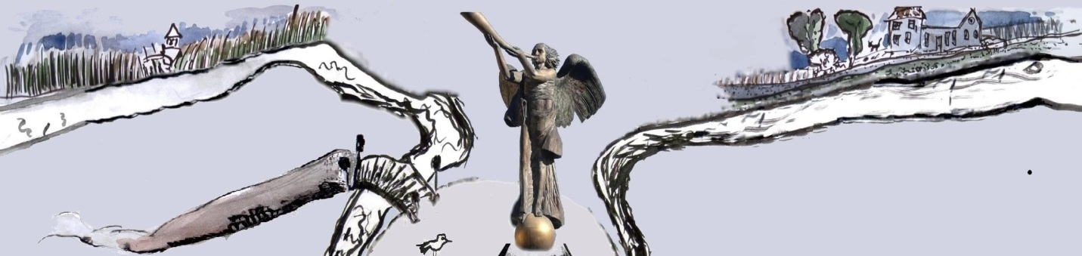
Republique d‘Ouzhoupis * Republic of Uzhupis * Užupio respublika

Ministry of Foreign Affairs
Nr.342
13.11.2012

This is to certify that Ms. Fiona Frazer has been accredited as an Amb@ssador of the Independent Republic of Uzhupis on Primrose Hill
Amb@ssador extraordinary and plenipotentiary has a right to:
1. accredite consuls on her territory after consulting the Minister of Foreign Affairs.
2. establish and run an Embassy of Uzhupis republic on Primrose Hill and the Primrose Hill Embassy in Uzhupis republic (on Basteja Hill);
3. share a London culture in Uzhupis; promote uzhupian ideas and the spirit of our community in London; assist Uzhupis events in UK.
4. study and lecture in Uzhupis University (Faculties of Human Rights, Flowers Education).
5. enjoy life and sustain in people the feeling of life as Sledging towards a Primrose.

minister of foreign affairs president of Uzhupis
of Uzhupis republic republic

Tomas Čepaitis Romas Lileikis

Ambassador is welcome in the Facebook group Užupis Republic Ambassadors and should create the page of the Embassy on www.uzhupisembassy.eu

